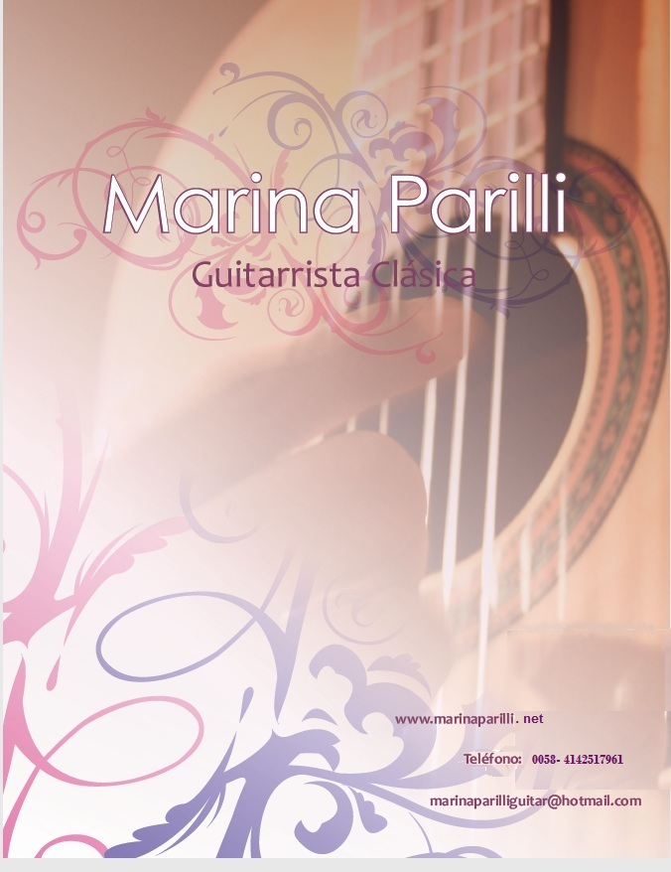
Marina Parilli
Marina Parilli: "Brilliant Virtuous of the Guitar, her talent, the passion, and her perseverance,
together with the parallel assimilation of the universal culture of the guitar, have been
determining factors in her artistic formation"
Marina Parilli: "The guitarist of sensibility and poetry"
Maestro Alirio Díaz

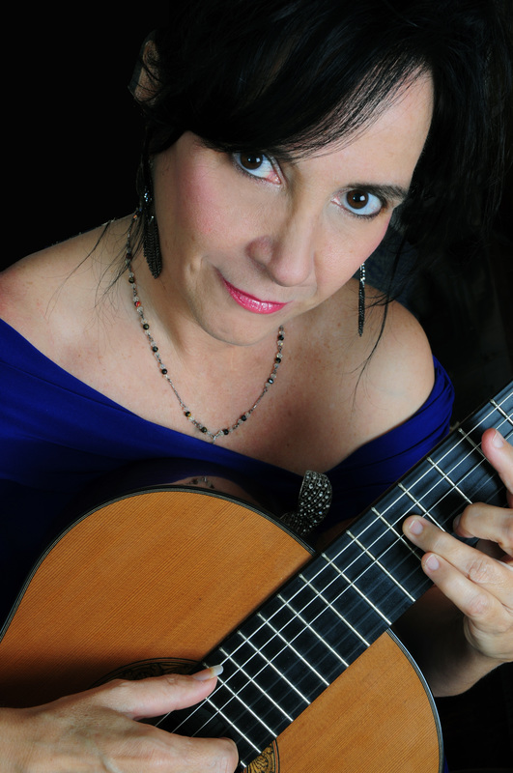

Biography

​The guitarist Marina Parilli is a well known Classical Guitar Master in Venezuela, and Latin America making her one of the best known artists of her generation. Her interpretations have been highly acclaimed with excellent critics and recognition from the audiences and the press. Her extensive repertoire includes music from all eras, and styles showing a special interest in the study, and interpretation of Iberoamerican music. She has participated in a series of concerts for solo guitar, and orchestra. She has performed in important theaters, and international guitar festivals.
Marina Parilli began her musical studies at Conservatorio Nacional de Música de Caracas, “Juan José Landaeta.” There she studied Classical Guitar for five years with the well known guitarist and composer Antonio Lauro.
In 1982 she traveled to Spain under a full scholarship by the Fundación Gran Mariscal de Ayacucho, to study for six years at the Conservatorio Superior de Música de Alicante, with the well renown pedagogist, and Master of the guitar José Tomás Pérez. There she earned the “ Grado Medio” and the title of “Grado Superior en Música” with a concentration in Guitar. At the same time she took Master Classes with John Williams, David Russell, Leo Brouwer, José Luis Rodrigo, Leopoldo Igarza, Luis Zea, Abraham Abreu, and world renown Master Alirio Díaz.
​In 1987 she moved back to Caracas where she worked as a teacher, and a concertist. She teaches at the Conservatory of Music Juan José Landaeta, and Prudencio Esaa and Lino Gallardo, where she created the “Cátedra de Iniciación a la guitarra para niños” (“Introduction of the guitar for children”) named by Master Ángel Sauce.
​Among other she has been a jury participant at the IV and VI Concurso Nacional de Guitarra “Antonio Lauro” and the XVIII Concurso Internacional “Alirio Díaz. She is well known as the author of “Introduction to the Guitar I and II- a step by step method for children”. She participated in the production of Antonio Lauro, and it’s best performers
Marina Parilli has appeared as a soloist with Jóvenes Arcos de Venezuela and Orquesta Juvenil Chacao in the IV and IX “Festivales de Orquestas Sifónicas Mirandinos.” She also participated in the 4th edition of the “ Festival, Guitarra & Mujer” in Asunción, Paraguay. In 2013 the “Festival Internacional de Guitarra de Maracay” as well in Choroní, Venezuela. The “Festival Académico Internacional de Guatire” in 2009 and in 2011 she participated in the “Festival de Guitarras del Mundo” in Argentina. “Festival Internacional Guitarras Latinas” in the city of Buenos Aires. “Festivales Internacionales FIGA 2009, and 2015” in the city of Bolívar, Venezuela. In Valencia, and Carabobo with the Symphony Orchestra in August of 2015. She also performed the world premiere of Concierto No I for guitar and orchestra of the Brazilian composer Aleh Ferreira in the “ XVIII Concurso Internacional Alirio Díaz” in which she received the condecoration “Orden Maestro Alirio Díaz in his unique class”

CONCERT PROGRAM

Classical Guitar Marina Parilli

- El testamento de Amelia (Canción catalana). . . . . . . . . . . . . . . . . . . . . . . . . . . . . . Miguel llovet
- Capricho árabe. . . . . . . . . . . . . . . . . . . . . . . . . . . . . . . . . . . . . . . . . . . . . . . . .Francisco Tárrega
- Asturias. . . . . . . . . . . . . . . . . . . . . . . . . . . . . . . . . . . . . . . . . . Isaac Albèniz (Revisión Alirio Díaz)
- Adagio (Homenaje a Johann Sebastian Bach). . . . . . . . . . . . . . . . . . . . . . . . . . . - Gerard Drozd
- Fantasía. . . . . . . . . . . . . . . . . . . . . . . . . . . . . . Alonso Mudarra (Arreg. y Digitación: Alirio Díaz)
Piezas venezolanas (armonización y revisión para guitarra Alirio Díaz):

- Como llora una estrella. . . . . . . . . . . . . . . . . . . . . . . . . . . . . . . . . . . . . . . . . . . . . Antonio Carrillo
- Dos valses venezolanos: Angostura y Natalia. . . . . . . . . . . . . . . . . . . . . . . . . . . . . . . . . . . . . . .
- Pasaje Aragueño y Petronila. . . . . . . . . . . . . . . . . . . . . . . . . . . . . . Antonio Lauro (Rev. A. Díaz)
- Así te soñé. . . . . . . . . . . . . . . . . . . . . . . . . . . . . . . . . . . . . . . . . . . . . . . . . . .Rafael Miguel López
- El gallo. . . . . . . . . . . . . . . . . . . . . . . . . . . . . . . . . . . . . . . . . . . . . . . . . . . . .Pedro Manuel Torres

-Tres pasajes originales para el arpa llanera venezolana. . . . . . . . . . . . . . . . . . . . . . . . . . . . . . . .
. . . . . . . . . . . . . . . . . . . . . . . . . . . . .Ignacio “Indio” Figueredo (Arreglos para guitarra Alirio Díaz)
- Los caujaritos
- Mi camaguán
- Priva Resuello

Dos piezas latinoamericanas::

- Confesión Romanza. . . . . . . . . . . . . . . . . . . . . . . . . . . . . . . . . . . . . . . Agustín Barrios Mangoré
- Danza paraguaya nº 1. . . . . . . . . . . . . . . . . . . . . . . . . . . . . . . (Revisión y digitación: Alirio Díaz)

- Sunburst . . . . . . . . . . . . . . . . . . . . . . . . . . . . . . . . . . . . . . . . . . . . . . . . . . . . . . . . . . Andrew York

Bis (La mariposa- Francisco Tárrega)

________________________

